July 22, 2011

Mayor Tomas Regalado
City of Miami
3500 Pan American Drive
Miami, FL 33133

Honorable Mayor Regalado:

On behalf of the Board of Directors of the Kiwanis Club of Little Havana, I am expressing our support to the re-construction and development of the Marine Stadium at the Rickenbacker Causeway.

Our city deserves a state of the art marine stadium from where to conduct aquatic activities, concerts and special events, portraying Miami’s beautiful skyline.

As an organization, we support the restoration of the Miami Marine Stadium and pledge to celebrate many events once completed.

Sincerely yours,
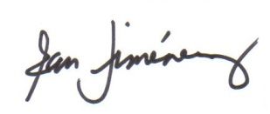
Ross Jimenez
President

Cc: Commissioners:
Wilfredo Gort
Marc Sarnoff
Frank Carollo
Francis Suarez
Richard Dunn

Don Worth, Friends of Miami Marine Stadium

