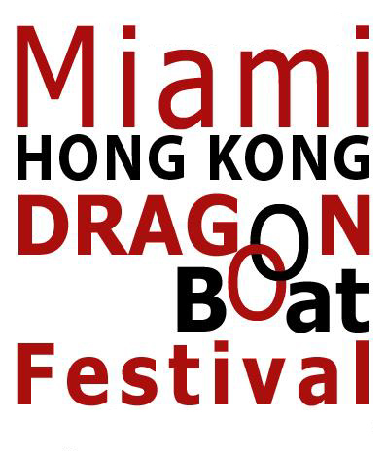
Miami Dragon Boat Club
2340 N.W. 27th Avenue
Miami, FL 33142
Tel: 305-636-0902 / Fax: 305-636-0910
miamidragon@bellsouth.net
www.miamidragon.com

April 4, 2008

Friends of Marine Stadium
c/o Dade Heritage Trust
190 SE 12th Terrace
Miami, FL 33131

At a meeting on April 4, 2008, the Executive Committee of the Miami Dragon Boat Club voted to endorse the effort to restore and revive Miami Marine Stadium. We are pleased to be part of the Friends of the Marine Stadium group.

Founded in 2003, the Miami Dragon Club has over 200 members. Dragon boat racing is the fastest growing outdoor watersport in the world. In other cities in the United States and Canada, watching dragon boat racing has become a very popular spectator sport. There are over 60 million people in the world who have raced dragon boats broken down into the following numbers: 50 million in China, 10 million in the rest of Asia, 3 million in Europe and about 2 million in the American hemisphere. The establishment of dragon boating in the Marine Stadium will turn Miami with its perfect year round weather into a Mecca of the dragon boating world with obvious benefits for one of our main industries which is tourism.

We have our dragon boats in the Virginia Key basin next to the Stadium. Renewal of the Stadium would allow us to have dragon boat races there that can become spectator events. We could also race dragon boats as a “halftime event” to planned concerts at the Stadium, generating the type of creative programming that could only be done in a special place like the Marine Stadium.
A revived Marine Stadium can be a tremendous asset to the Miami Dragon Boat Club-and to the community as a whole. We enthusiastically support this effort.

Yours truly,

Joe Chi
President
Miami Dragon Boat Club
www.miamidragon.com

